Your name and your student number: Maciej Czerniak, 243552
Your mentor: Alician Noyan
The student number of the person you are reviewing: 245769

Question 1. The student submitted 3 masks: Yes/No, if no, list the missing masks.

YES, the student submitted 3 masks: Shoot, Seed, Root

Name of the image file: train_Alican_245769_im1.png

 | Shoot Mask | Seed Mask | Root Mask
Req 1 | PASS | PASS | PASS
Req 2 | PASS | PASS | PASS
Req 3 | PASS | PASS | PASS
Req 4 | PASS | PASS | PASS

Requirement 5 can be found on the next page

Requirement 5:
- Incorrect Root Border
  - Roots are labeled thinner than they actually are (under labeled):
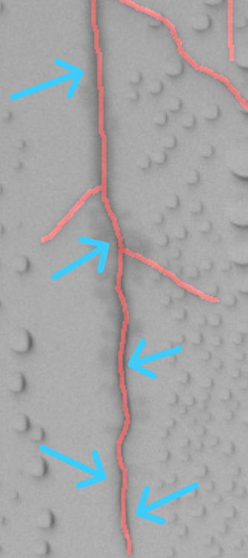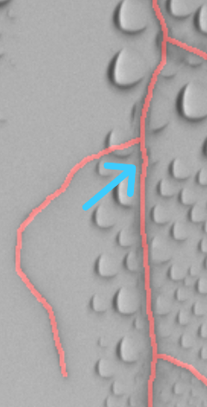
Plant 1 Plant 5
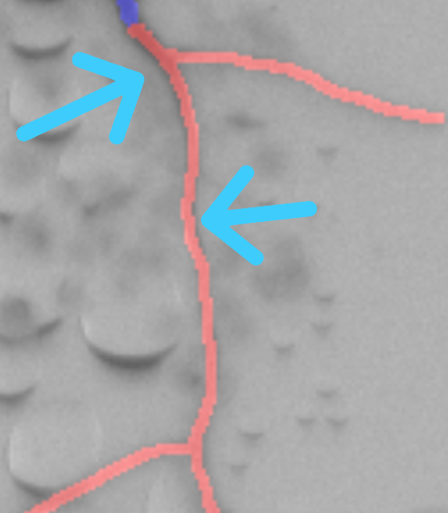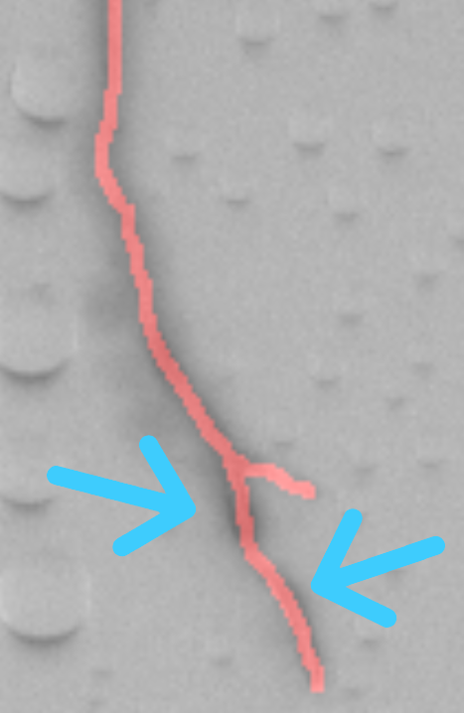
Plant 3 Plant3
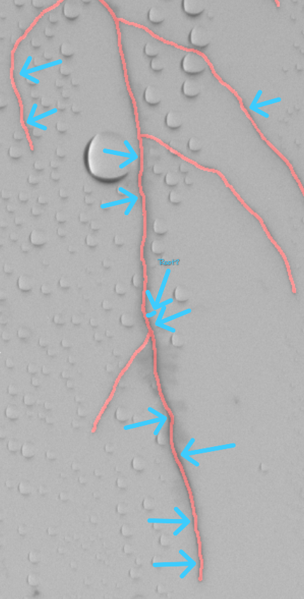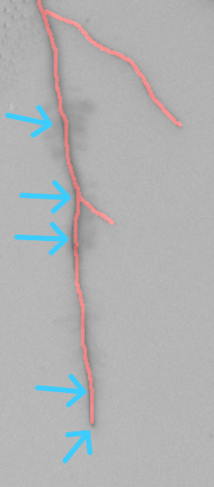
Plant 4 Plant 5
- Missed Roots
  - Roots that should be labeled are not labeled.
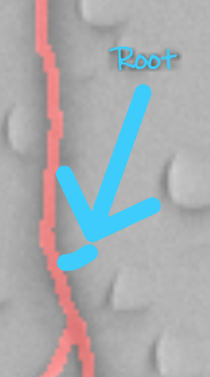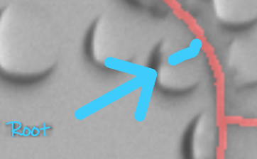
Plant 4 Plant 5
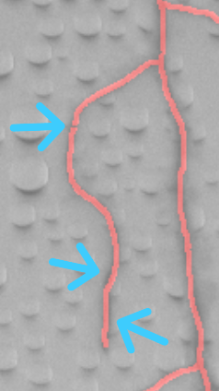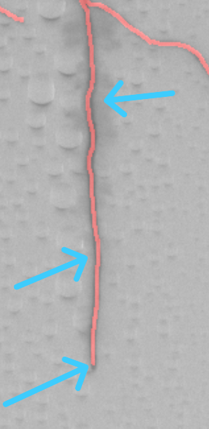
- Incorrect Shoot Border
  - Shoot are labeled thinner than they actually are (under labeled):
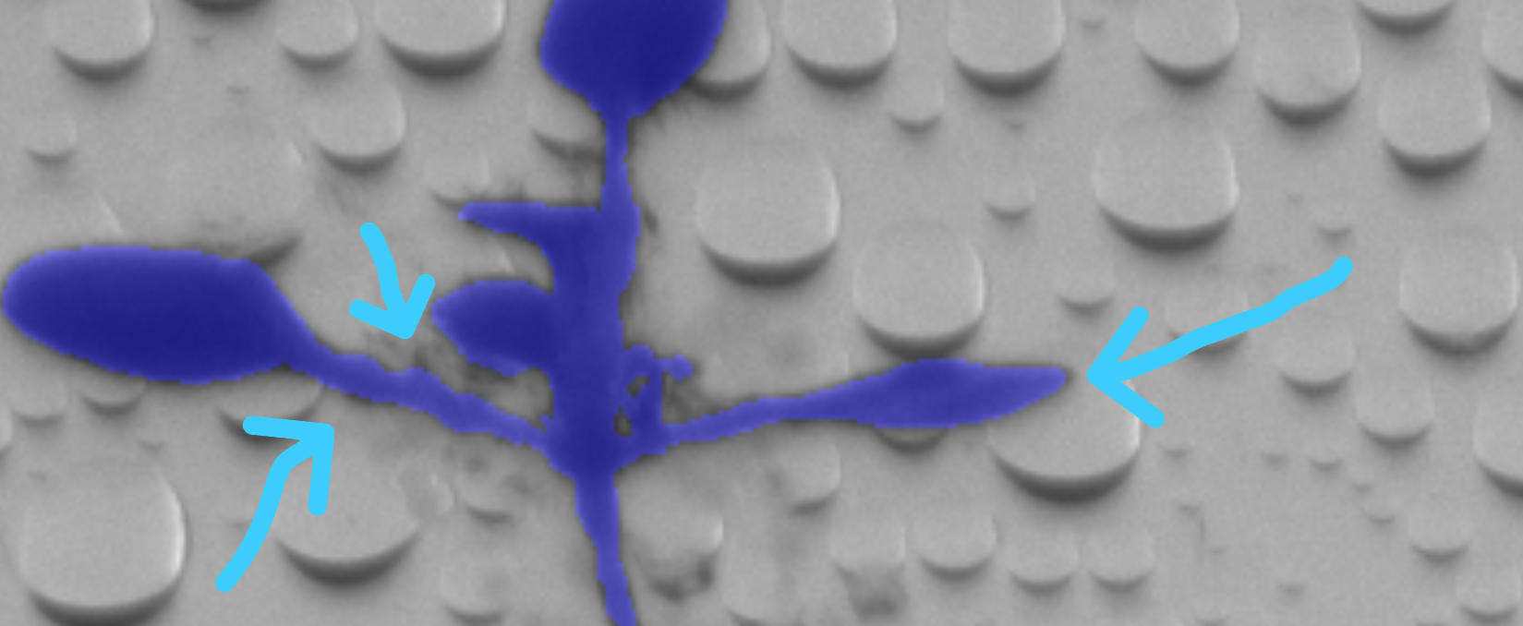
Plant 2
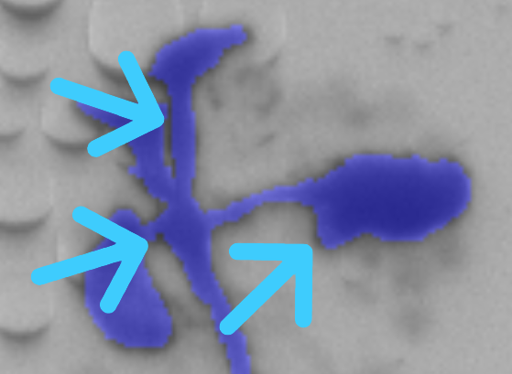
Plant 3
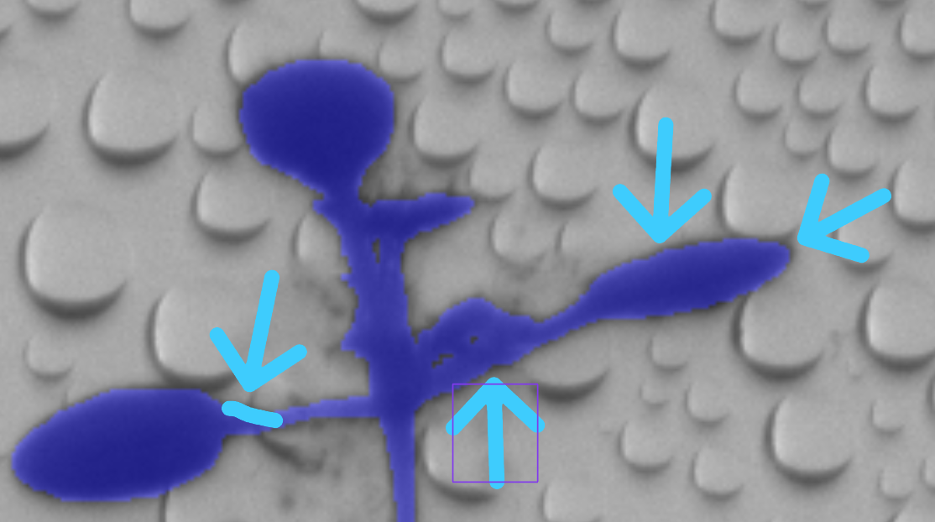
Plant 4
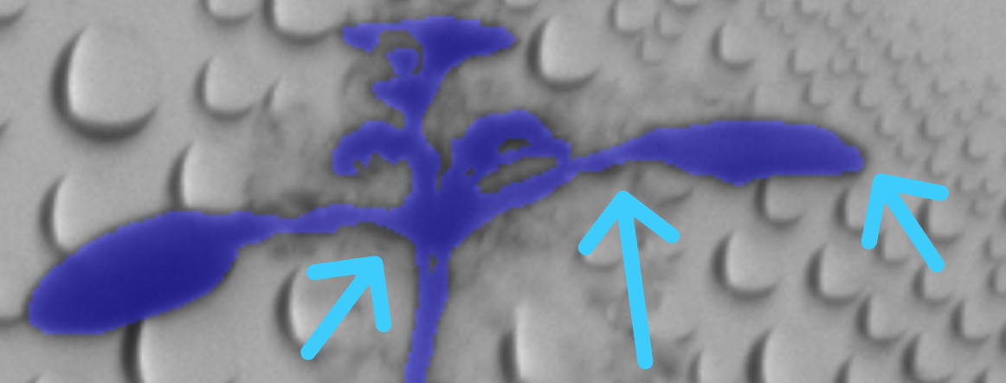
Plant 5
- Missed Shoots
  - Shoots that should be labeled are not labelled:
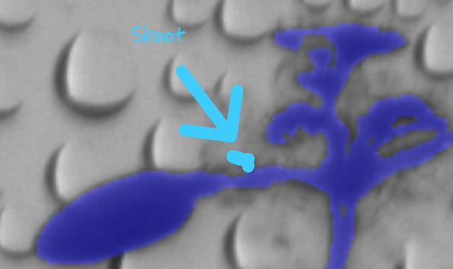

Plant 5

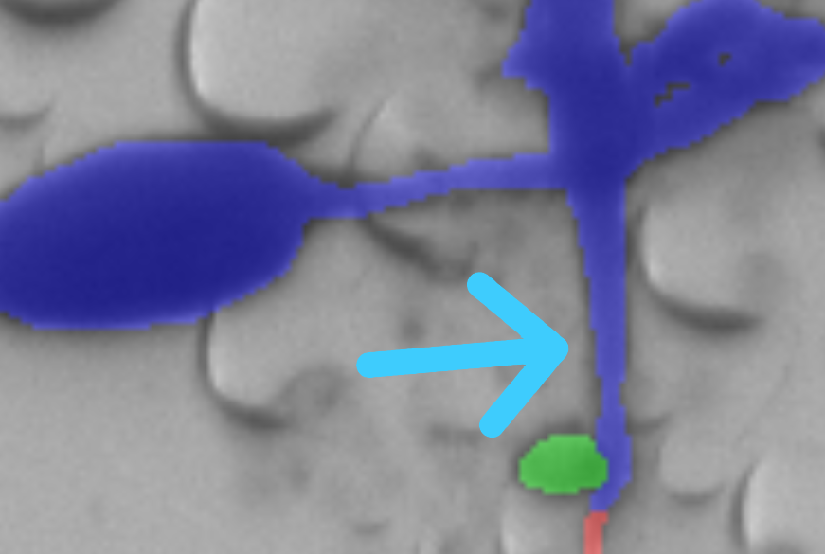
Plant 4
- Incorrect Seeds Border
  - Seeds are labeled thinner than they actually are (under labeled):
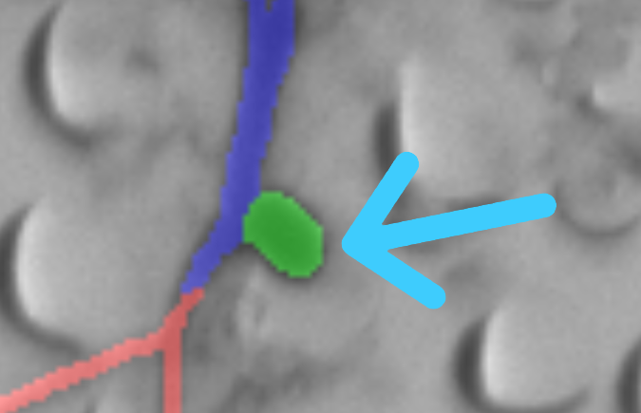

Plant 5

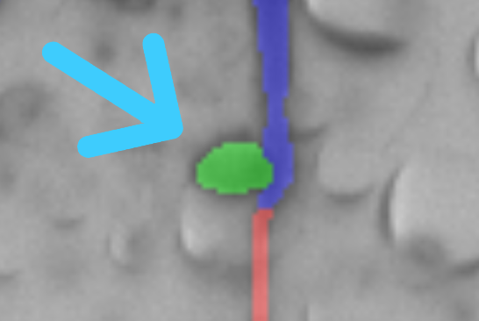

Plant 4

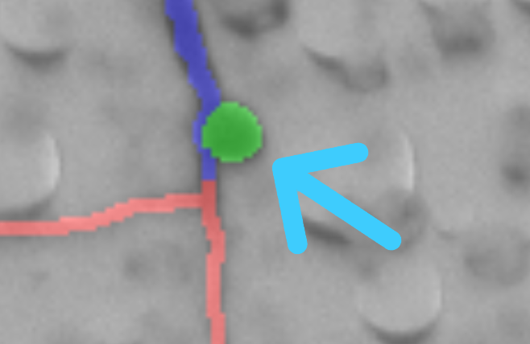

Plant 2

